Story 07 Update a Book

## Description

As a user

I want to update a book of the collection

So that the updated book will be stored in the database

## Wireframe

Happy case:

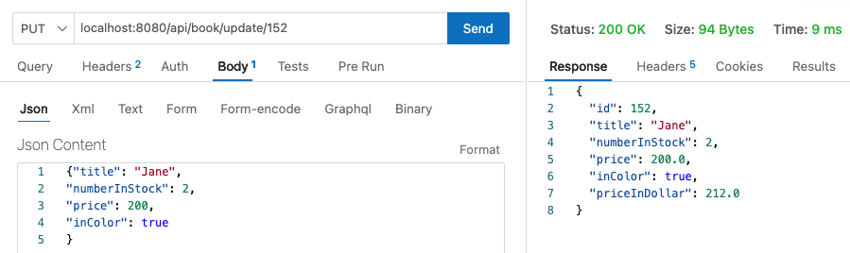

Unhappy case – Title is not unique:

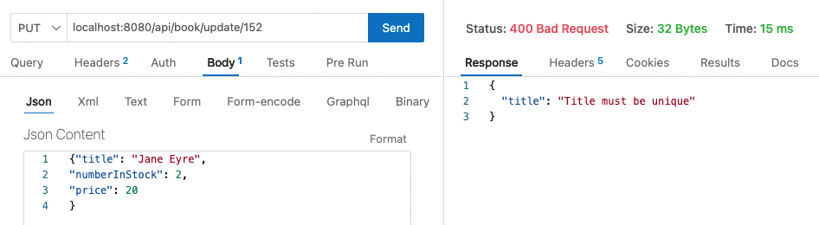

Unhappy case – Field errors:

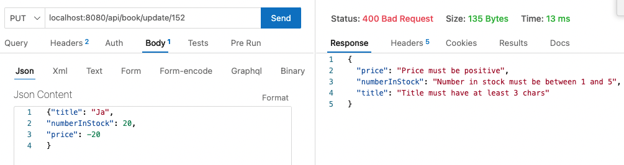

Unhappy case – Invalid id:

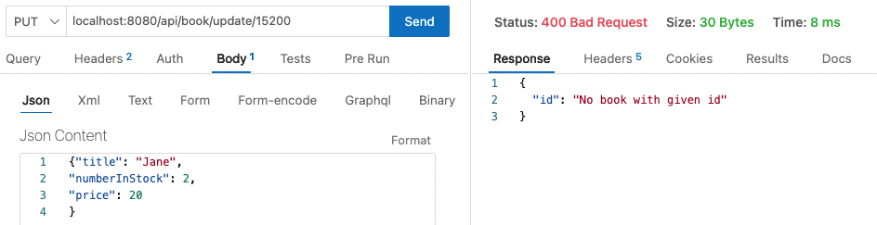

## Acceptance Criteria

|  |  |
| --- | --- |
| Request | PUT |
| URL | http://localhost:8080/api/book/update/{id} |
| Path Variable | Id (int) |
| Request Body | A Book object (JSON) – fields: title, numberInstock, price, inColor |
| Output: happy case | A Book object (JSON) – all fields |
| Output: unhappy case | Response 400 BAD REQUEST  JSON error messages with field(s) as shown in wireframe (see also list below) |
| Acceptance Criteria | The book with given id is updated with the values of the fields in the request body  Returns the updated book |

Error messages and corresponding field:

* "id": "No book with given id"
* "price": "Price must be positive"
* "numberInStock": "Number in stock must be between 1 and 5"
* "title": "Title must have at least 3 chars"
* "title": "Title is required"
* "title": "Title must be unique"